i. API Documentation

<https://app.swaggerhub.com/apis-docs/sepulsa/RentABook-API/1.0.0#/Authentication/reqAuthGetToken>

ii. API Server

<https://app.swaggerhub.com/apis-docs/sepulsa/RentABook-API/1.0.0>

GET : <https://virtserver.swaggerhub.com/sepulsa/RentABook-API/1.0.0/client/1>

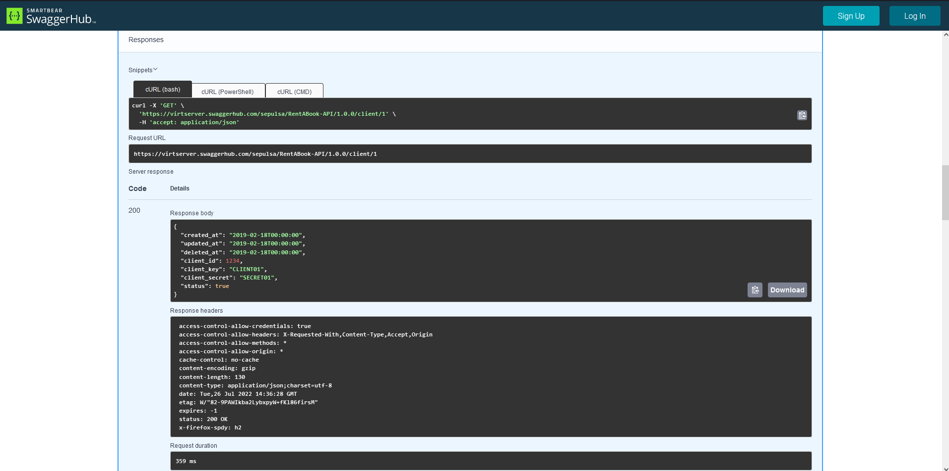

POST : <https://virtserver.swaggerhub.com/sepulsa/RentABook-API/1.0.0/client>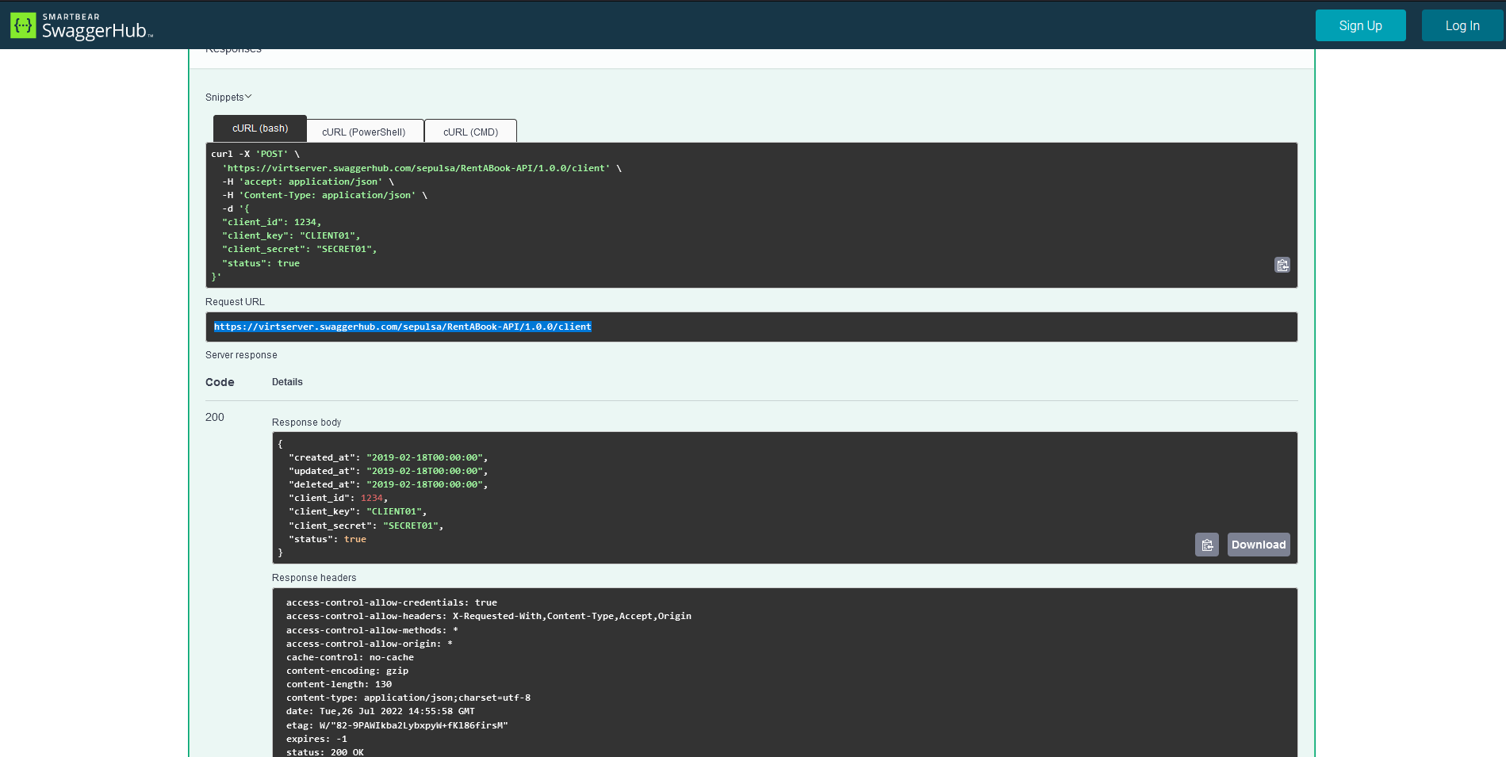

PUT : <https://virtserver.swaggerhub.com/sepulsa/RentABook-API/1.0.0/user/1>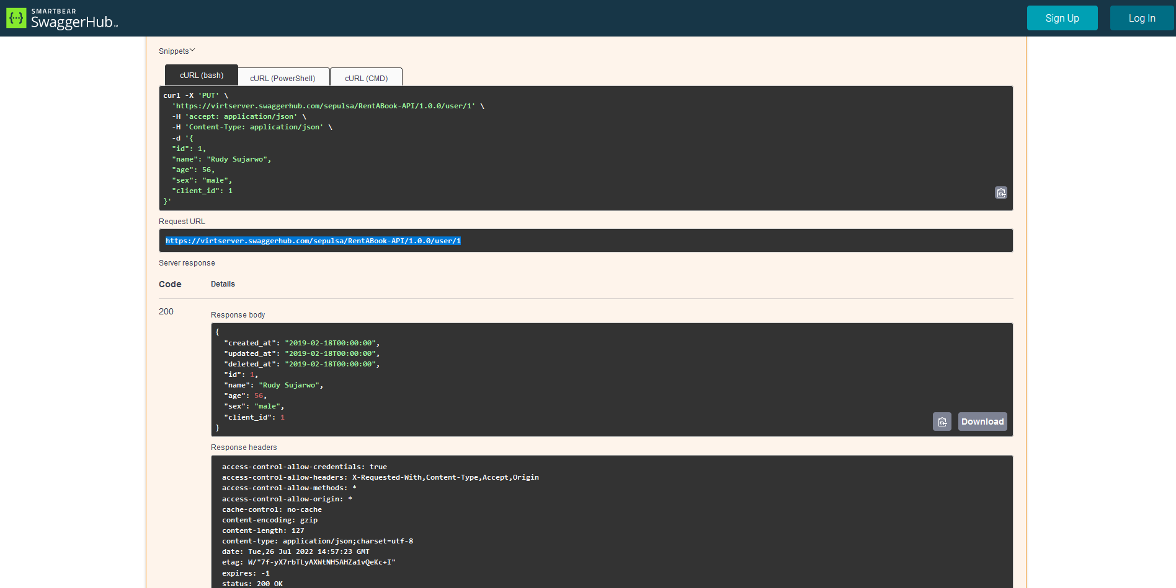

DELETE : <https://virtserver.swaggerhub.com/sepulsa/RentABook-API/1.0.0/book/2>

